TTO-81760-00L
电气参数Electronical characteristics
产品型号 Production model | TTO-81760-00
额定输出功率 Rated output power | AC 750VA
初级额定电压 Primary Rated voltage | AC 115V，230V
额定频率 Rated ferquency | 50-60Hz
次级空载电压 Secondary no-load voltage | AC 8.37V±5%
次级负载电压/电流 Secondary loaded voltage / current | AC 8.0V±5%@93.75A
初级空载电流 Primary exciting current | Max. 120mA(初级额定输入电压Primary rated input voltage)
安全标准 Safety standard | UL Class F 绝缘系统( UL Class F insulation system F83 E226166)
绝缘等级 Insulation class | Class F (155Deg.C) CE
接地系统Ground system | Class-II
温升Temperature rise | 105Deg.C Max.(额定输入at reted input)
外施耐压试验Dielectric Withstand Test | AC 4000V 5mA 1 分钟Minute(初级对次级Primary to Secondary)
感应耐压试验Induced withstand voltage test | AC 460V 400Hz 15S(次级Secondary )
绝缘电阻试验Measurement of dry insulation-resistance | 100M OHM @ DC 500V
安装尺寸Installation size | 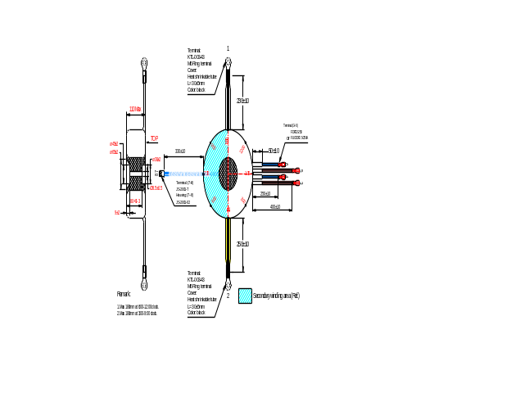

附项选择 additional item
温度保护 Thermal Protector | 无No，但可根据客户要求增加No,but can increase according to customer’s requirement.
短路保护 Short-circuit Protector | 无No，但可根据客户要求增加No,but can increase according to customer’s requirement.
五金配件 Hardware accessories | 胶垫Neoprene washe： Φ8.5x150mm 1个  平垫圈Flat washer： M8 1个  弹簧垫圈Spring washer： M8 1个  六角螺丝Hex secews: M8x90mm 1个  螺母Nut: M8 1个
静电屏蔽 Electronic shielding | 无No，但可根据客户要求增加No,but can increase according to customer’s requirement.
电磁屏蔽 Magnetic shielding | 无No，但可根据客户要求增加No,but can increase according to customer’s requirement.
中心孔灌环氧树脂 Filled epoxy resin | 有Yes.

